Home Assignments
1) With vibe coding implement the playwright/typescript or any other tool which you work say Selenium/Python

Sample prompt for playwright/typescript integration:
Ask mode :
Read my entire workspace and confirm me what are the files will be impacted if I want to add playwright typescript same like implemented for
Selenium Java

Prompt for agent mode :

Read the Entire workspace and understand how I implemented the selenium Java

I want to add the playwright typescript

1.Go to prompts.js and add new prompt templates for Playwright TypeScript
Take selenium Java as reference

PLAYWRIGHT_TYPESCRIPT_PAGE_ONLY
PLAYWRIGHT_TYPESCRIPT_WITH_CUCUMBER
CUCUMBER_WITH_PLAYWRIGHT_TYPESCRIPT_STEPS

2 .Go to chat.js

Update getPromptKeys() method to handle Playwright/TypeScript combinations

3.Go to panel.html

Add the logics to handle playwright typescript same like selenium Java

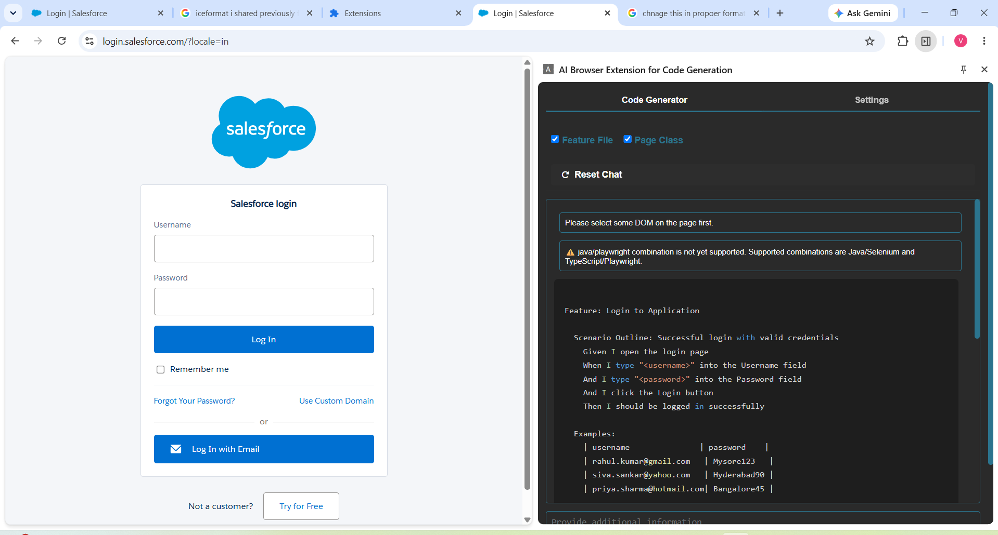

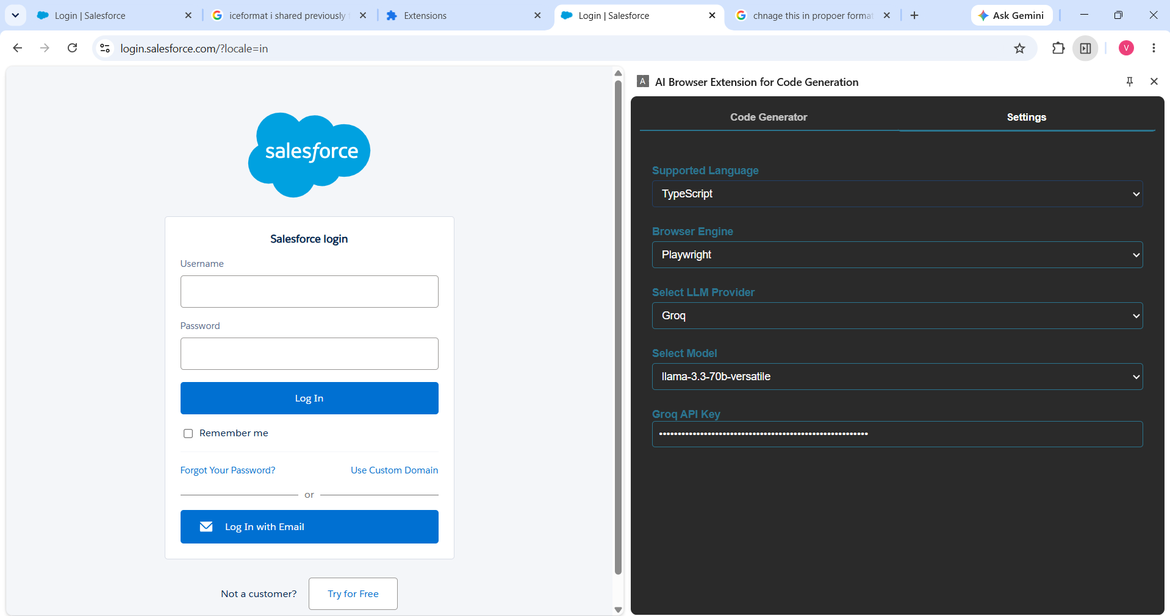
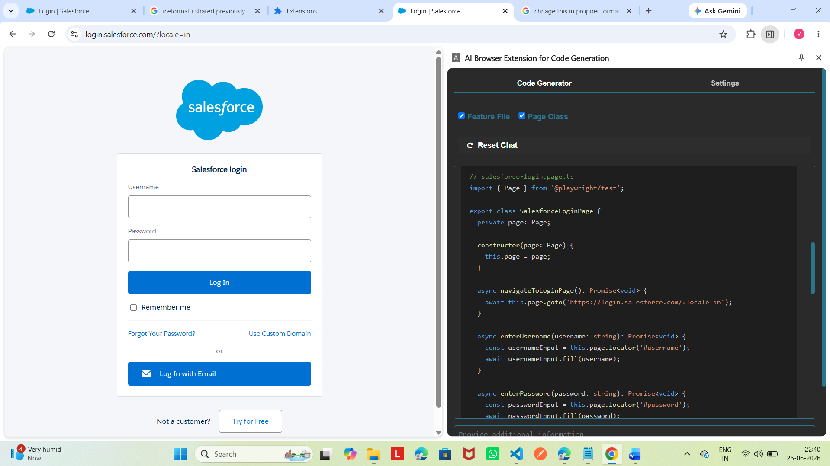
Edge extension
